- State Machine Diagram cho developer dễ hiểu hơn 1 usecase: mô hình hóa luồng dữ liệu, xem xét tổng thể main flow, alternative flow, exceptions dưới dạng diagram

# Register

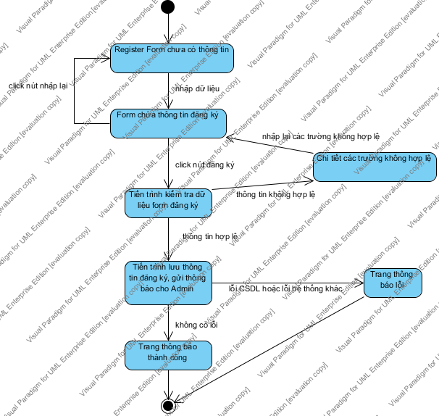

State Machine Diagram

# ThayDoiThongTinCaNhan

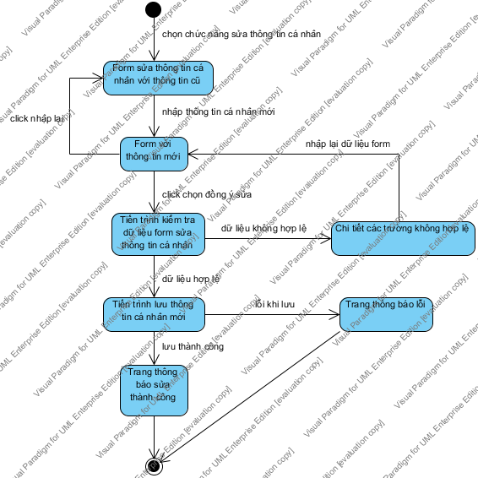

State Machine Diagram

# CapNhatGioHang

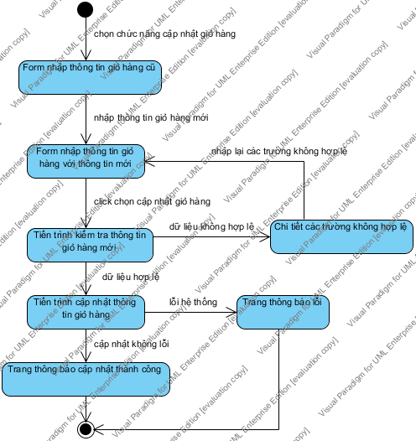

State Machine Diagram

# GuiDonHang

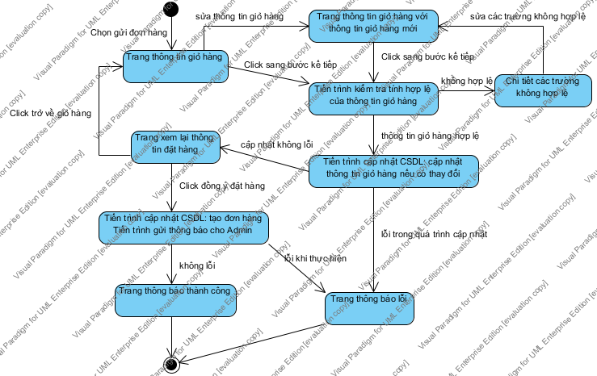

State Machine Diagram

# ThemPhimVaoGioHang

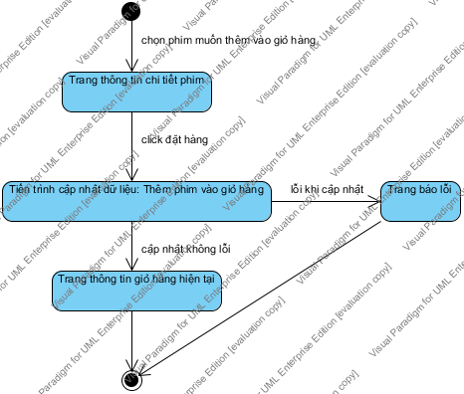

State Machine Diagram

# LuuPhieuXuat

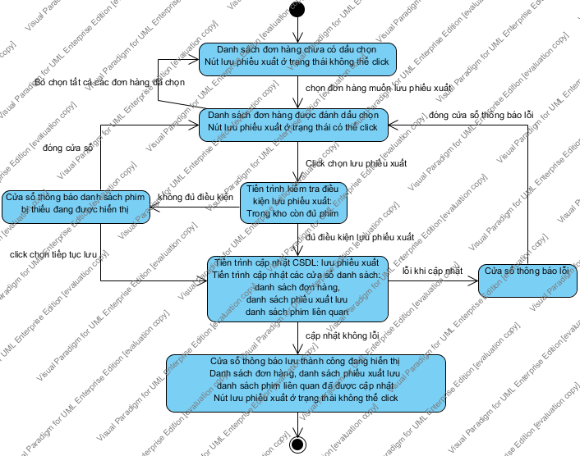

State Machine Diagram

# XoaDonHang

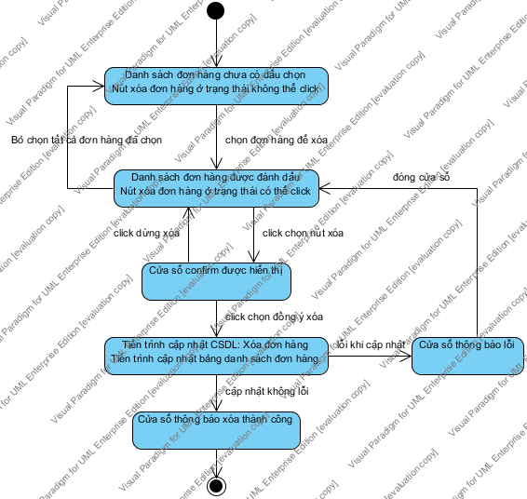

State Machine Diagram

# ThemPhimVaoDonHang

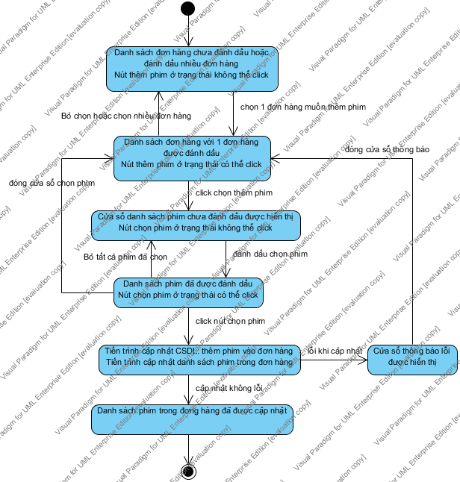

State Machine Diagram

# BoPhimKhoiDonHang

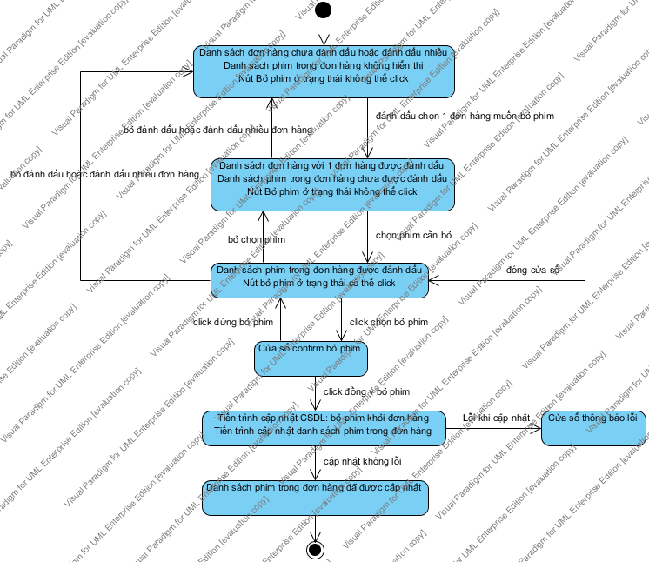

State Machine Diagram

# SuaDiaChiGiaoHang

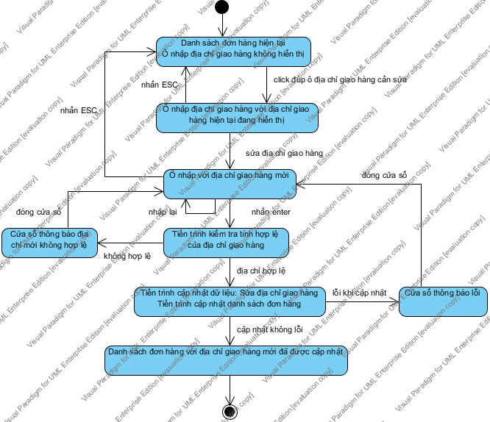

State Machine Diagram

# SuaDienThoaiLienHeGiaoHang

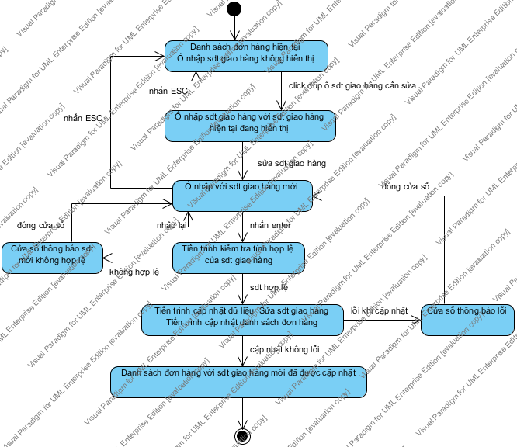

State Machine Diagram

# SuaSoLuongPhimTrongDonHang

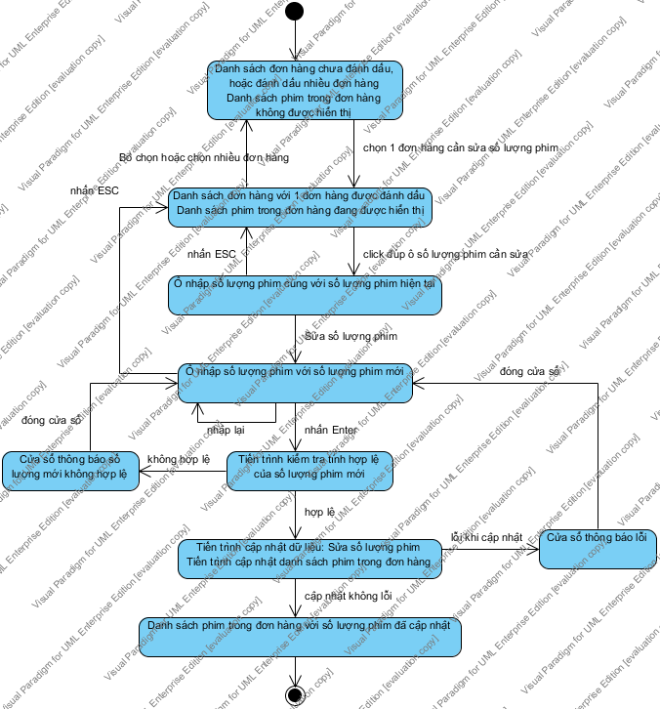

State Machine Diagram

# SuaEmailGiaoHang

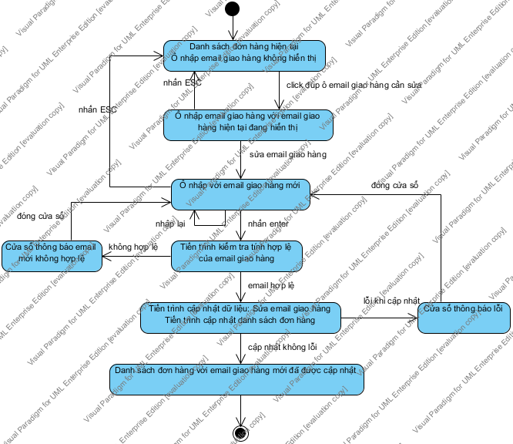

State Machine Diagram

# SuaGiaPhimTrongDonHang

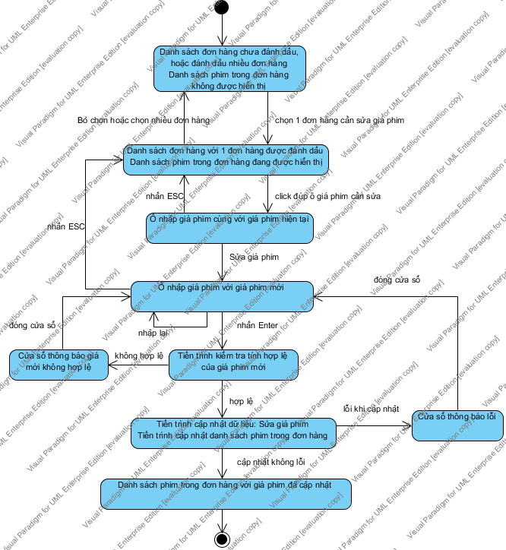

State Machine Diagram

# SuaTiLeGiamGiaTrongDonHang

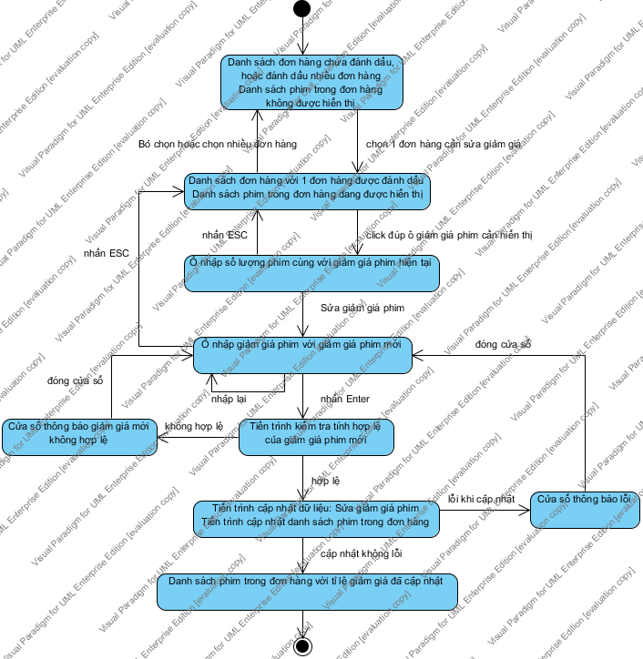

State Machine Diagram

# XuatThongTinLichSuMuaHang

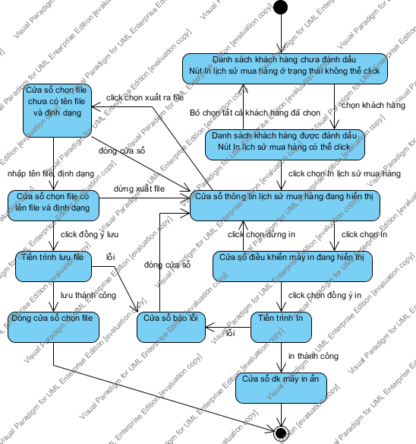

State Machine Diagram

# XoaThongTinKhachHang

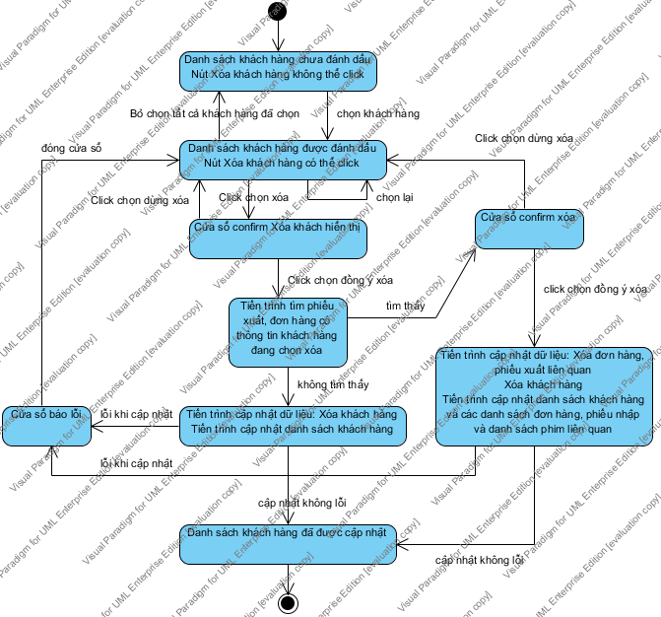

State Machine Diagram

# XuatDuLieuPhieuXuat

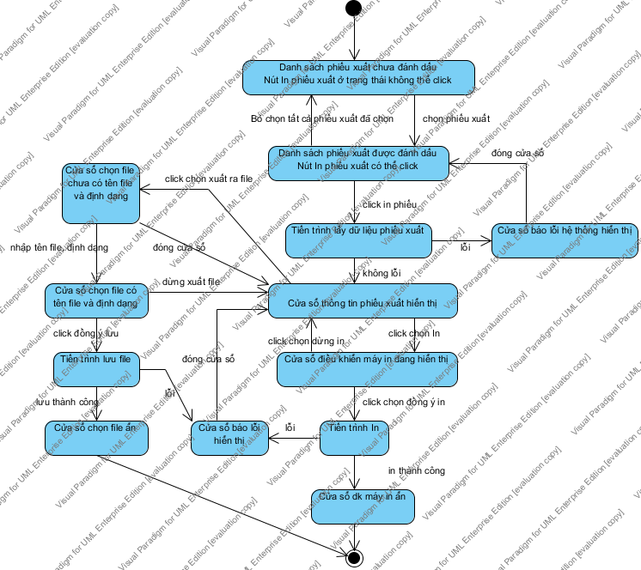

State Machine Diagram

# ThemMoiNhaCungCap

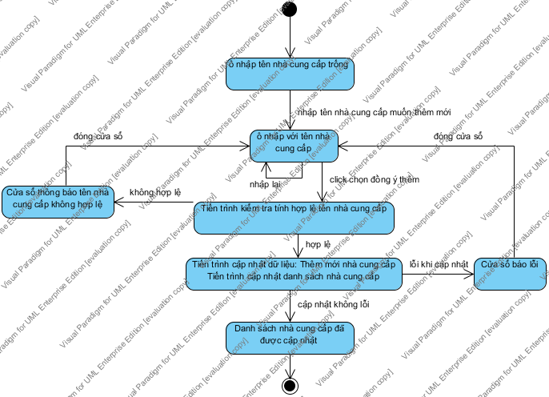

State Machine Diagram

# ThemMoiLoaiPhim

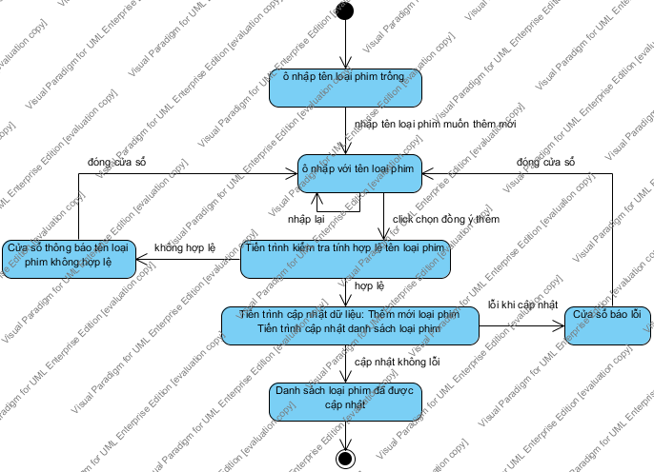

State Machine Diagram

# ThemMoiDaoDien

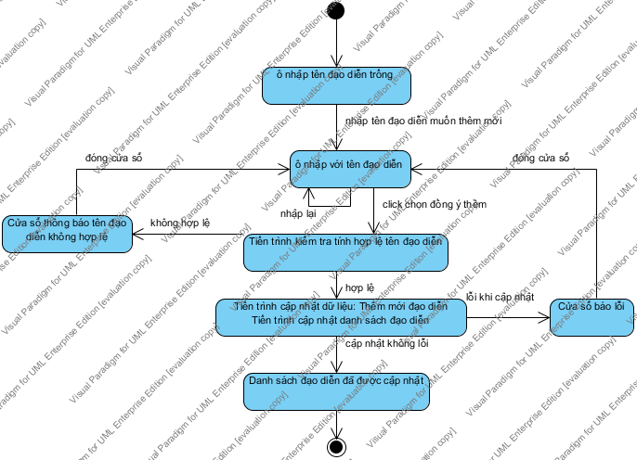

State Machine Diagram

# ThemMoiDienVien

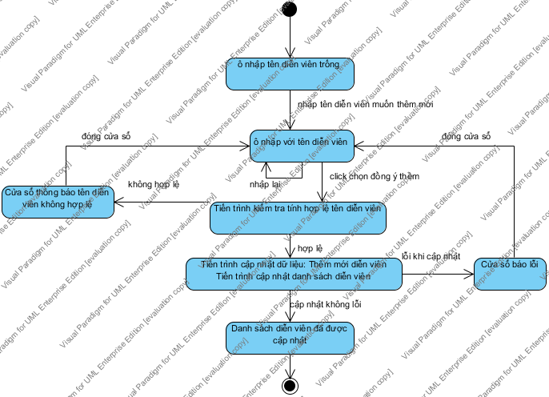

State Machine Diagram

# ThemNickChat

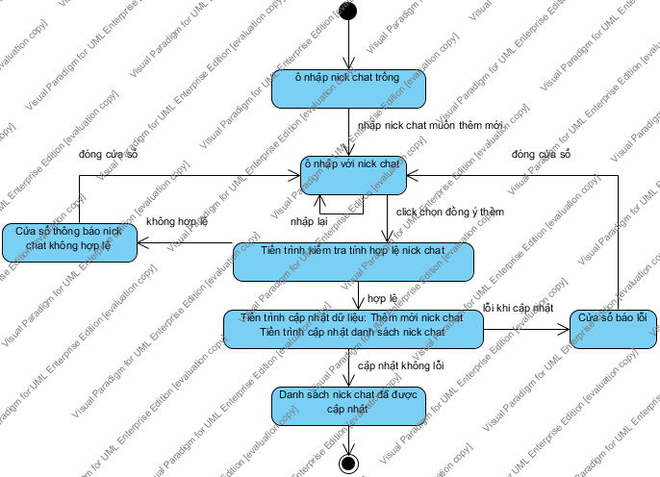

State Machine Diagram

# SuaNhaCungCap

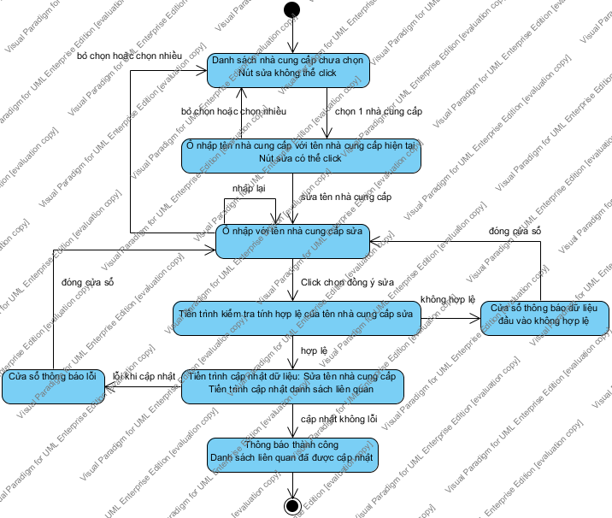

State Machine Diagram

# SuaLoaiPhim

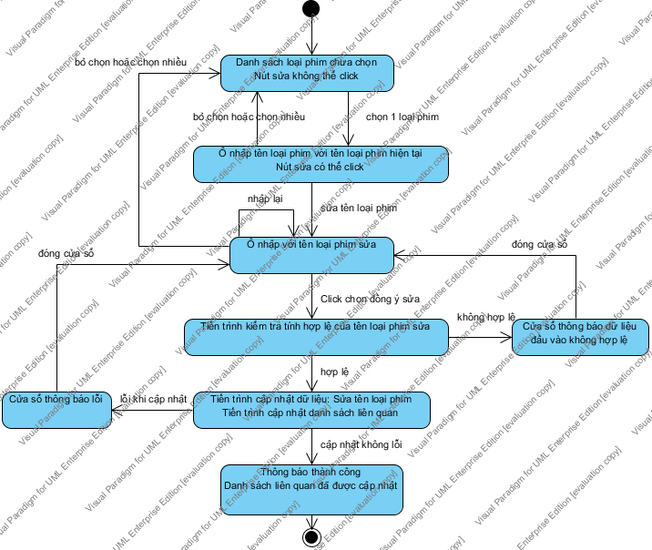

State Machine Diagram

# SuaDaoDien

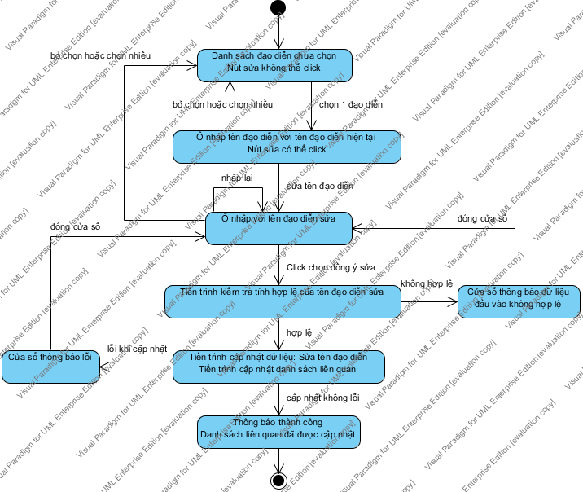

State Machine Diagram

# SuaDienVien

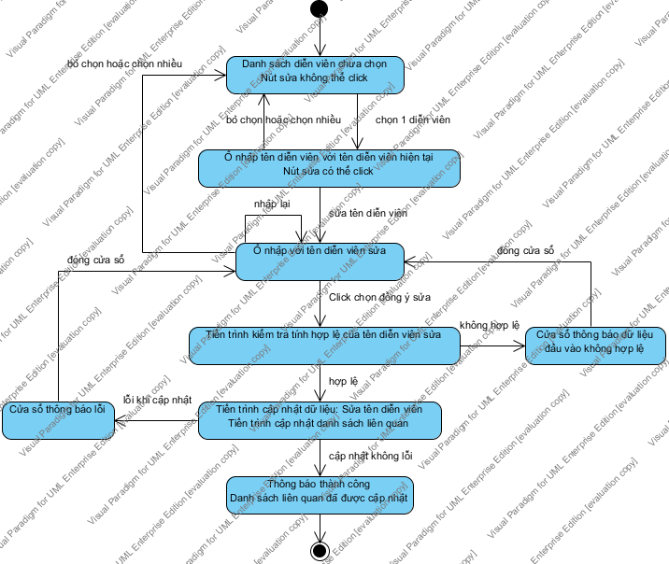

State Machine Diagram

# SuaNickChat

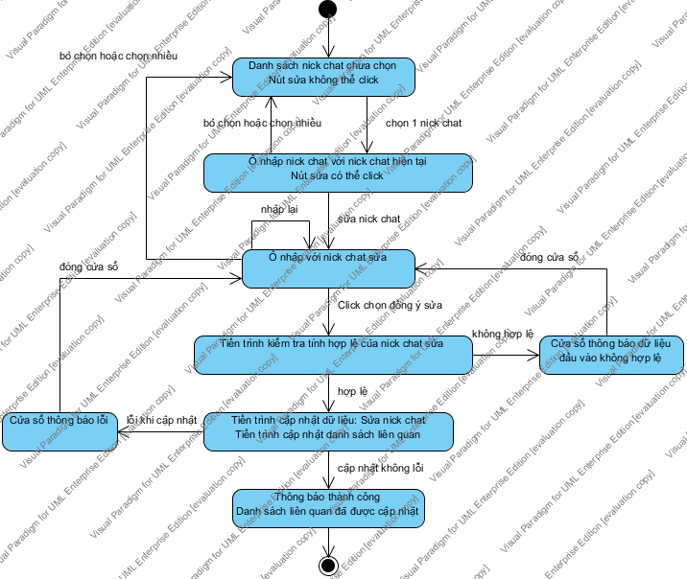

State Machine Diagram

# XoaNhaCungCap

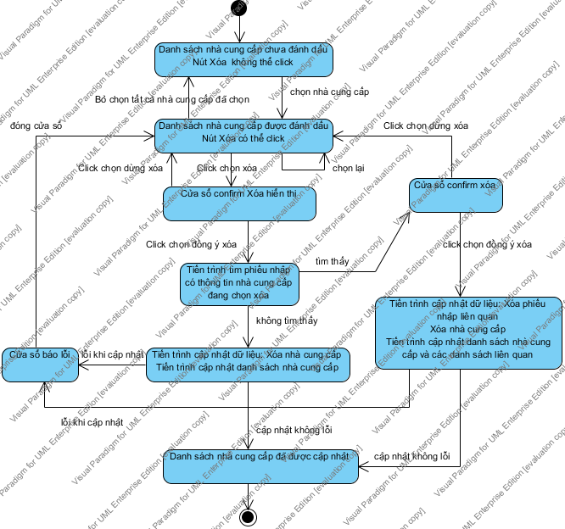

State Machine Diagram

# XuatDuLieuBaoCao

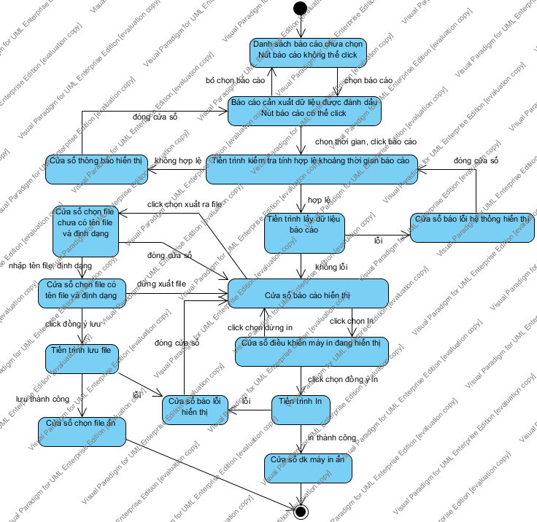

State Machine Diagram

# SuaCaiDatHeThong

